About the Collaborative
The purpose of Olympic Forest Collaborative is to create healthier ecosystems on the Olympic Peninsula, supporting high-quality watersheds and vibrant populations of fish and wildlife, while providing economic benefits to local timber-oriented communities through increased levels of sustainable timber harvest on the Olympic National Forest. Collaborative members – including stakeholders from the timber industry, the environmental community, and representatives from local and federal government – work together to realize these goals.
Authors
Paul Fisher, Miles LeFevre, and Dr. Sean Jeronimo – Resilient Forestry
Contributors
Jill Silver – 10,000 Years Institute
David Marshall – Sierra Pacific Industries
Dr. Bernard Bormann – Olympic Natural Resources Center, University of Washington
Dr. Patricia Jones – Olympic Forest Coalition
Acknowledgements
Olympic Forest Collaborative wishes to thank Dr. Bernard Bormann for his tireless energy and commitment to learning from our forests and for his generous contributions to this effort. Thanks also to our partners at the Olympic National Forest for their review of this document and helpful feedback. This work was funded by the Washington State Department of Natural Resources through Cross-Boundary Grant number 93-098589 and All-Lands Grant number 93-100572. In-kind support for Dr. Bormann’s time was provided by the University of Washington School of Environmental and Forest Sciences’ Olympic Natural Resources Center.

Errors are the authors’, not of the agencies, funding sources, or contributors.

Contents
Background and Motivation 1
Monitoring Protocol Summary 1
1. Photo Points 2
2. Interpretive Hiking Trails 2
3. Vegetation Measurements 2
4. Wildlife Habitat Measurements 2
5. Aquatic Condition and Habitat Measurements 3
6. Specific Harvest-related Outcomes 3
Vegetation Monitoring Protocol 4
Purpose of the Vegetation Monitoring Protocol 4
METHODS PART A: PREPARATION AND LOCATING PLOTS 4
In-Office Preparation 4
Equipment 4
METHODS PART B: DATA COLLECTION 5
Plot Layout Diagram 5
Navigation to Plot and Plot Data 5
Tree Data 6
Woody Debris Transects 6
4) Vegetation Data 8
PLOT CLOSEOUT 9
MEASUREMENT STANDARDS 10
1) Point of measure for DBH 10
2) Compacted Crown 12
3) Snag Decay Classes 12
4) Percent Cover Estimation 13
5) Species Code List 14
Imagery Field Guide 15
Purpose of Photo-Point Monitoring Protocol 15
In Office Preparation 15
Equipment 15
DATA COLLECTION 15
Location 15
Point Photography 16
Drone Photography 16
Learning Framework 18
Applying the framework 19
Step 1. Identify key questions and associated learning methods (cycle through step 2 and back enough times to end with a formal question priority) 19
Step 2. Assess relevance to future decisions (cycle back to step 1 enough times to end with a formal question priority) 19
Step 3. Determine practicality and effectiveness of learning method needed to address each question (then cycle back to question list) 20
Step 4. Choose the minimum set of measures needed to answer the question (again cycle back to earlier steps as needed, especially when measures prove unpractical) 21
Step 5. Analyze data and put into a broader context of what is known before drawing conclusions (after measures have come in) 22
Step 6. Find ways to effectively share conclusions, and accept alternate conclusions 22
Literature cited 22
Study Plan: Queets Corner 23
Introduction 23
Key questions 23
Potential additional questions 23
Expected outcomes (hypotheses) 23

Background and Motivation
Olympic Forest Collaborative (OFC) was initiated in 2013-2014 by US Representative Derek Kilmer as a key element of an effort to increase the total timber volume harvested from the Olympic National Forest (ONF), stabilize and support the local timber-focused economy, and improve forest and watershed health across the Olympic Peninsula. OFC was organized as a functioning entity by 2015, and has since been continually working with the ONF to plan and implement restoration thinning projects yielding both merchantable timber and improved ecological conditions. Revenue from these projects is invested back into the ONF to accomplish additional restoration work on the Forest, such as culvert replacement and wildlife habitat enhancement. To date, OFC has taken on seven such projects treating a total of approximately 800 acres, and two additional projects totaling nearly 500 acres of potential treatments are currently in planning phases.
OFC’s early efforts focused on building trust among members, creating a framework of agreement on the type and locations of forest restoration treatments, and learning how to productively engage with the ONF to reduce the time and cost required to plan and prepare projects. As projects proceeded to implementation, the need was recognized to collect post-treatment data to monitor for effectiveness in creating desired forest conditions. Over time, OFC has come to value quantitative treatment monitoring as the best way to verify that project implementation matches planned treatments, understand project outcomes, identify required adaptations for future work, and communicate project results to a broader audience.
This document serves to formalize OFC’s treatment monitoring program, in recognition that every Collaborative project should be monitored thoroughly and uniformly to highlight the meaningful ecological changes effected by treatments and to allow for direct comparisons among Collaborative projects.
The overarching goal of OFC’s monitoring is to quantify the outcomes of forest management actions, track how well forest conditions are approaching the desired forest conditions, and to inform best management practices in future ONF timber harvest projects.
A secondary goal of OFC’s monitoring work is to supply the ONF with data characterizing the changes to forest stands brought about by thinning treatments. While the Forest Service does monitor at a regional level for late successional forests, habitat of certain species, and watershed conditions, the ONF does not have a stand-level treatment monitoring program. We hope that pre- and post-treatment data collected by OFC and made available to the public will provide insights into the ecological impacts and benefits of forest thinning on the ONF and build trust between the ONF and interested members of the public.

Monitoring Plan Summary
The OFC Monitoring Plan includes six approaches to observing changes to forests: (1) photo points, (2) informative hiking trails, (3) vegetation monitoring, (4) wildlife and habitat use monitoring, (5) aquatic habitat condition and response, and (6) studying specific harvest-related outcomes.
As part of the development of the vegetation monitoring protocol, we evaluated other monitoring protocols (e.g., Forest Service Ecology Plots, FIA, WA Dept. of Natural Resources Forest Health Monitoring) to ensure that the data collected using this protocol had sufficient overlap to be comparable to other protocols used in the region. While there are differences between each of these protocols and the OFC protocol, all protocols used fixed radius plots to describe overstory and understory trees, including species, diameter and tree condition. All protocols had some form of monitoring understory vegetation cover, and all protocols described the characteristics of CWD. We believe that these similarities are sufficient to allow for comparisons of forest conditions between properties monitored with this and other protocols.

Photo Points
Photo points are permanent locations from which photographs are taken pre-harvest (where possible), and at regular intervals following harvest. These time-series photos show the changes to the forest. Several photo points will be established at each harvest area, and landmarked on-the-ground and with GPS so they can be re-used over time. Drone aerial imagery may also be used.
Objective: Provide photographic documentation of changes to specific points in the forest over time.
Methods: Photographs from permanent, landmarked points at intervals over time.

Interpretive Hiking Trails
Seeing the forest with your own eyes is the best way to understand the impacts and benefits of forest management. OFC will develop short hiking trails through harvested areas, passing by key features in the harvest such as canopy openings, no-cut skips, or other unique areas within the harvest area.
Objective: Provide easy access for people to see different harvest practices and the forest response.
Methods: Identify unique features in the harvest area and create a trail that passes through these features. Interpretive signs are a goal, to be developed. Implementation of this monitoring goal will require analysis under NEPA and so must be included in project planning.

Vegetation Measurements
Tracking the condition of forest species is at the heart of forest management. Installing tree and vegetation measurement plots pre-harvest (where possible) and post-harvest will allow OFC to monitor how well treatments are shifting forest conditions towards target conditions.
Objective: Quantify the transition of forests towards OFC’s target conditions, specifically tree and understory species composition, size, density, and volume, relative to no-treat areas and to reference condition data. Report this information simply and clearly to OFC members and other stakeholders.
Methods: Install permanent plots in harvest areas, measuring overstory trees and understory vegetation pre-harvest (where possible) and post-harvest, with the option of long-term measurements (i.e., decadal) as resources allow. Plot measurements will include spatial mapping of trees and GPS points of plot locations allow correlation with LiDAR and other remote-sensed information. Plots will include no-treatment skips to show the outcomes of no management.

Wildlife Habitat Measurements
Observing wildlife habitat features can inform OFC of what wildlife are using the forest and how forest management changes wildlife habitat. Observations of habitat features, forage species, and evidence of use by wildlife will indicate the effects of forest management on the potential for wildlife use.
Objective: Quantify suitable shrub and forb forage/habitat for songbirds, quantify suitable habitat for cavity-nesting birds, small mammals, amphibians, and ungulates.
Methods: In vegetation monitoring plots, measure snags, note existing cavities, identify and estimate shrub and forb species and cover, and note browse signs. Installation of game cameras is a goal to be developed in future iterations of this protocol.

Aquatic Condition and Habitat Measurements
Placeholder for future protocol development.

Specific Harvest-related Outcomes
OFC has the opportunity to try unique approaches to forest management. Monitoring the effects of specific management actions will help inform future projects. For example, if a thinning prescription includes creating relatively large canopy openings (up to around 2 acres), we know that windthrow (wind toppling live trees) will likely result. Monitoring the extent and patterns of windthrow will help future forest managers in designing canopy opening to meet their objectives.
Objective: Quantify the effects of specific, unique forest management approaches to inform best management practices.
Methods: To be determined based on the specific questions.

Vegetation Monitoring Protocol

Purpose of the Vegetation Monitoring Protocol
Olympic Forest Collaborative (OFC) is monitoring forest management actions taking place on the Olympic National Forest that have OFC involvement. The overarching goal of monitoring is to quantify the outcomes of forest management actions, track how well forest conditions are approaching the desired forest conditions, and to inform best management practices in future ONF timber harvest projects.
Installing tree and vegetation measurement plots pre-harvest (where possible) and post-harvest will allow the OFC to monitor how well treatments are shifting forest conditions towards target conditions.
Objective: Quantify the transition of forests towards OFC’s target conditions. Specifically: Changes in tree species composition, size, density, and volume, as well as understory species diversity and downed wood relative to no-treat areas and to reference condition data.
Methods: Install permanent plots in harvest areas, measuring overstory trees and understory vegetation pre-harvest (where possible) and post-harvest, with the option of long-term measurements (i.e., decadal) as resources allow. Plot measurements will include spatial mapping of trees and understory vegetation and GPS points of plot locations allowing correlation with LiDAR and other remotely-sensed information.

METHODS PART A: PREPARATION AND LOCATING PLOTS

In-Office Preparation
- Select plot locations based on digital and field recon data (if available). Minimum 1 plot per 10 acres, and 5 plots per forest strata. Place plot randomly within each forest strata before making manual adjustments to plot locations to avoid logistical issues such as boundaries, access, and non-forest patches.
- Prepare digital maps for use in the field. Also export a layer of plot center points as a GPX and KML for use in navigation apps.
- Prepare data sheets – paper or digital.

Equipment
- Map of the unit with plots (digital)
- Data sheets (paper or digital)
  - If paper: bring extra datasheets, pencils, clipboard, and protective cover.
  - If digital: bring fully-charged tablet or smart phone, and ensure the datasheet is loaded on the device. Bring an external device charger if battery life could be an issue.
- These procedures (paper or digital)
- GPS device: Garmin GLO or similar for general navigation, WAAS-enabled and/or differentially-corrected GPS for plot centers
- 5 ft length of PVC pipe for plot center
- Tripod for GPS and/or laser, compass, as needed. If using a TruPulse360, the tripod and attachment must be non-magnetic
- Camera
- Reel tapes, at least 200 ft (or 50 m)
- Compass declinated to 16° E, or laser with internal compass such as a TruPulse 360
- Tree diameter measuring tape
- Laser hypsometer for distances and tree heights (extra batteries), with filter and reflector (optional)
- Increment borer
- Hammer or hatchet
- White spray paint for tree numbers
- Orange spray paint for plot center
- Yellow or white flagging for in-plot marking
- Biltmore stick

METHODS PART B: DATA COLLECTION

Plot Layout Diagram
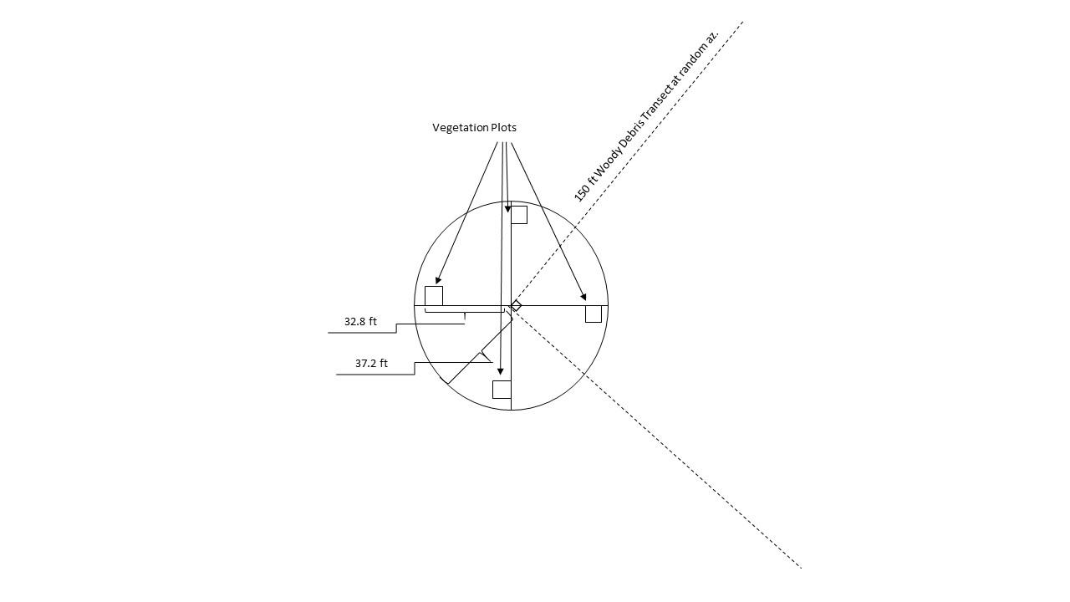

Navigation to Plot and Plot Data
- Navigate to plot center. Install PVC pipe so about 3 ft are above ground. Spray paint with orange. Write the plot ID on the PVC pipe using a Sharpie. The plot center may be offset by 100 ft along a random azimuth if there are hazards or non-forest at the original plot center (cliff, stream, bees, road, etc.).
- Take photos of the plot that capture the forest conditions (rather than along cardinal directions). Include a panoramic photo from plot center. Record the azimuth of each photo.
- Choose a large-diameter tree that is likely to be retained in a harvest as the bearing tree. On the back of a boundary tag, write the plot number, and distance and azimuth to the plot center. Record this information on the datasheet, as well as the tree species, DBH, and tree number.
- GPS the plot center using a device rated for sub-meter accuracy, letting the device average points for a minimum of 15 minutes. Label the point with the unit name and plot ID, followed with the 6-digit date as follows: Queets01_022019. If your GPS software allows, write down the GPS coordinates once the point is complete.
- Record date, surveyors present, project name, and sampling event (e.g. pre-treatment, post treatment, post treatment 2nd remeasure, etc.)

Tree Data

OVERSTORY TREES
1/10th ac (37.2 ft radius) for trees ≥8 in DBH both live and dead
- Number trees by using white spray paint to paint consecutive numbers below stump height, facing plot center. Start with the bearing tree as tree # 1 and work clockwise. Reset numbering at each new plot.
- Record azimuth to tree. Use a compass declinated to 16°.
- Record distance to tree. For trees on the edge of the plot boundary, measure horizontal distance (correct for slope) with a reel tape to determine if a tree is in.
- Record tree species and DBH. Paint a white dot at the location of DBH measurement on the uphill side of the tree.
- Record whether tree is live or dead. For snags, record decay class. Snags are any dead tree remnant taller than 4.5 ft and at least 8 in DBH, with less than 45° lean. Snags greater than 45° lean will be counted as woody debris.
- Record wildlife use observations: SR = stem rot, BR = approx. ≥4 in diameter branch, BP = branch platform, FT = forked top, BT = broken top, NC = nesting cavity/excavation present, BS = basal scar
- Height Trees: Record at least 6 heights per plot. Make sure to record at least one height per species present in the plot. If there are more than 6 tree species in the plot, record as many heights as species. Choose dominant or co-dominant trees to measure height.

SITE TREE
Use an increment borer to age one tree per plot. Age a site-tree (dominant, relatively full crown, typically Douglas-fir or western hemlock). Record age. Measure tree height if it hasn’t yet been recorded.

SMALL TREES
1/10th ac (37.2 ft radius) for trees 0.1-7.9 in DBH
- Count live trees in 2 in diameter bins, separated by species. For example, keep separate tallies of Sitka spruce that are between 0.1-1.9 in, 2-3.9 in, 4-5.9 in, and 6-7.9 in DBH.
- Use a Biltmore stick to quickly assess diameter. Use the vegetation protocol for seedlings up to 4.5 ft.

Woody Debris Transects
Lay out transects originating from plot center. The first transect is at a random azimuth. The second transect is +90° from the first transect. Transects extend 150 ft, centered on the plot center (75 ft extending both directions from plot center). Landmark the ends of the transects with PVC 1-2 ft above ground, painted orange.
Measure the diameter on each CWD piece (>2 in diameter) the transect crosses.
- Using a caliper or diameter tape, measure the diameter of each intersected CWD piece perpendicular to the intersection of the transect line and the centerline of the piece. Examples shown in the diagrams below.
- If the CWD is suspended out of reach on the transect line, estimate diameter and mark as “Estimated” in the plot data.
- Where the transect touches or crosses a portion of a piece (including stumps above HSG), measure and include the piece if the transect crosses at least 50% of the diameter (similar to a plot boundary tree).
- If the transact crosses a CWD piece and then subsequently crosses branches or other parts of that CWD piece, each piece is counted separately (i.e., it does not matter if the pieces are attached – see Figure 4).
- If the piece has split open or shattered, estimate the diameter of the piece as a whole, and do not additionally measure related pieces individually.
- Record the CWD pieces numbered sequentially in the plot data. Tagging or marking of measured CWD is not required.
- Record the decay class of the wood (scale of 1 through 5)

4) Vegetation Data
Establish four (4) 3x3 m (9.84x9.84 ft) vegetation plots per monitoring plot. Each plot is established 10 m (32.8 ft) from the monitoring plot center along each of the four cardinal directions.

Plot Setup
- From monitoring plot center, run 10 m on a straight line at each 0°, 90°, 180°, and 270° azimuth.
- Monument vegetation plot corner with PCV pipe.
  - At least 2 ft should be sticking out of the ground
  - Paint PVC with orange spray paint.
- Setup 3x3 m plot frame. Be care not to trample plants within the plot.
  - Mark the three remaining corners with temporary PVC poles 3 m apart at 90° angles to form a 3x3 m square. Plot should lay to the right and towards plot center from the monumented corner. Measure the hypotenuse (4.24 m, 13.9 ft) to ensure the plot is square.
  - Run a rope around each corner to form a box.
- Record plot number on datasheet. Vegetation plots should be numbered starting with monitoring plot number follow by a dash and then N, S, E, or W depending on plot azimuth. For example, vegetation plot of 90° azimuth for monitoring plot 10 will be assigned the ID: 10-E.

Biomass Estimation
- Each person stands at a different corner of the plot.
- Each person independently reviews the LTEP BioCube Book 1.0 for the photo that is most similar by openness and species mix. Record the photo number in personal notes.
- While looking at the photo, each person alters the total biomass to represent the proportional volume of vegetation actually in the 3x3 m.
- Record all photo numbers and biomass adjustments on the datasheet.
- Take at least 1 photo that includes the plot frame (with field data sheet in picture to identify).
These are the tree species typically found:
PSME=Douglas-fir; THSE=western hemlock; THPL=western red-cedar; ACMA=bigleaf maple
ALRU=red alder; TABR=Pacific yew; ABAM=Pacific silver fir, PISI=Sitka spruce
Non-Trees: CONU=Pacific dogwood; RHPU=cascara; ACCI=vine maple
Individuals that are taller than DBH WILL NOT be part of the BioCube weight. Individuals that are shorter than DBH WILL be part of the BioCube weight.

Understory Cover
- Distinguish understory plants from trees (all plants with DBH < 3.5 cm).
- Look for and identify each understory species by percent cover.
  - Total cover may exceed 100% due to overlapping plants.
  - Be thorough. It is important to get every species.
- For unknown species, make the best possible attempt to identify the species using Pojar and MacKinnon text (or similar).
- For unknown / un-identifiable species, list as Unk1, Unk2 etc. and percent cover.
- Observe the ground surface and record the percent cover of wood, bare ground, and large rocks, moss. (Moss is a single category. Do not identify moss by species.)

PLOT CLOSEOUT
- Copy any notes from Rite-in-the-Rain notebooks.
- Check over all data.
- Take a photo of each datasheet (if paper data was used).
- Remove all flagging and markings (except plot center monument, if used).
- File data sheets, if used.
- Download data from tablets/phones, if used. Clearly name data with plot number and date.
- Back-up all data.
- Charge GPS units, radios, tablets, etc.
- Replace used batteries.

MEASUREMENT STANDARDS

1) Point of measure for DBH
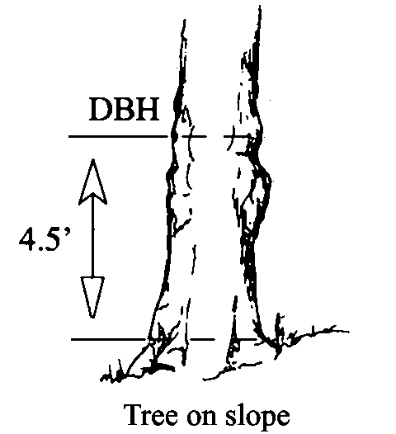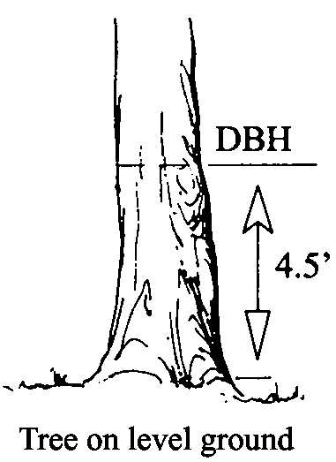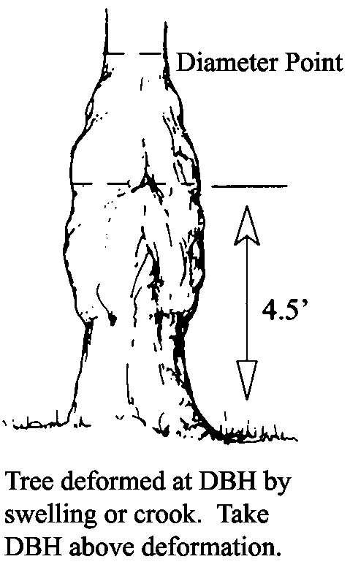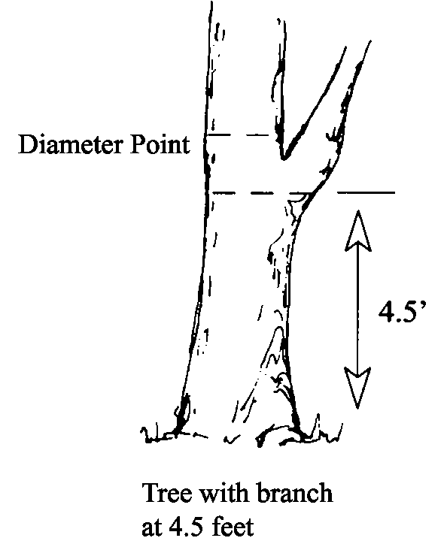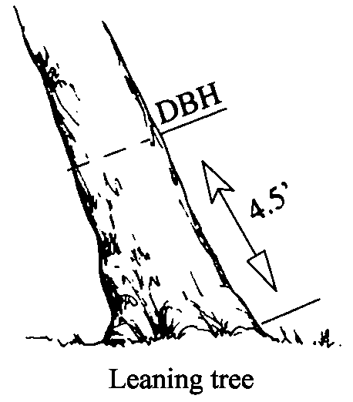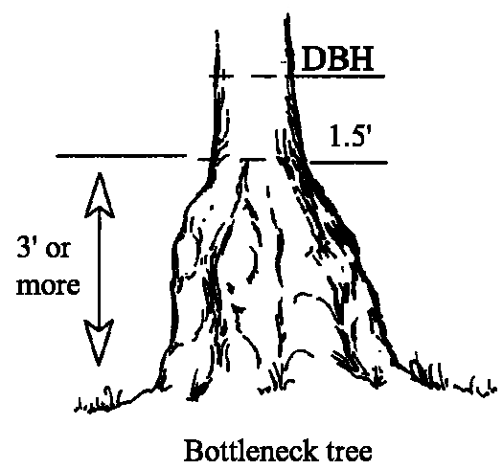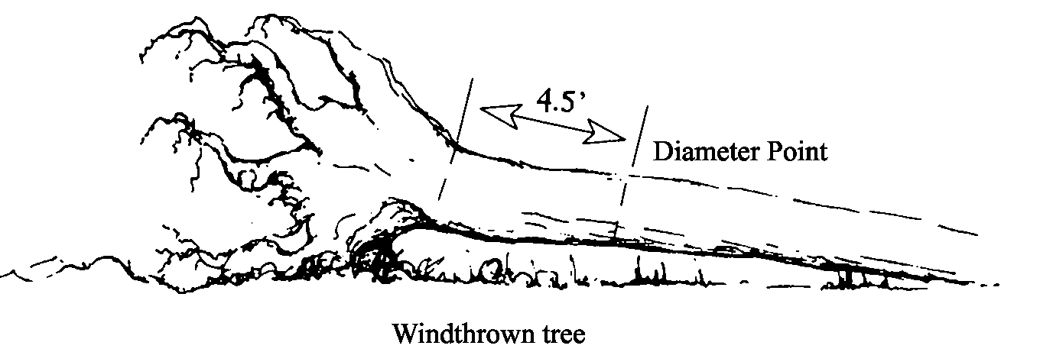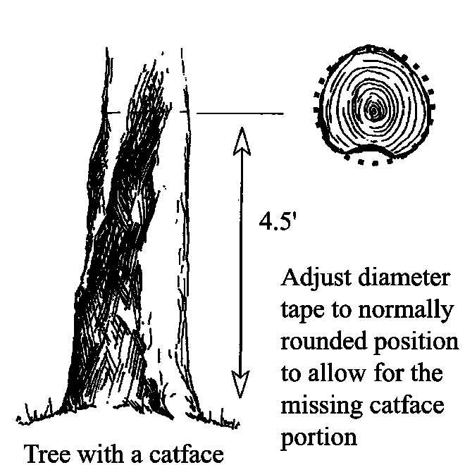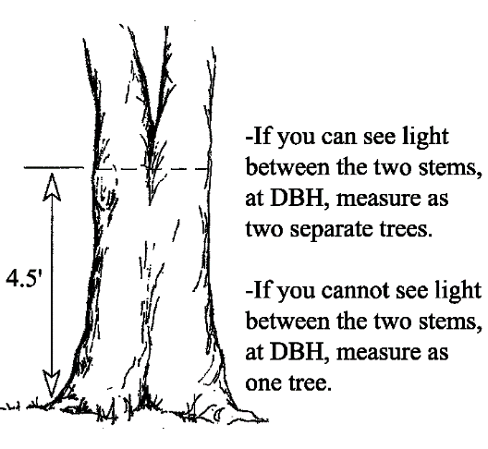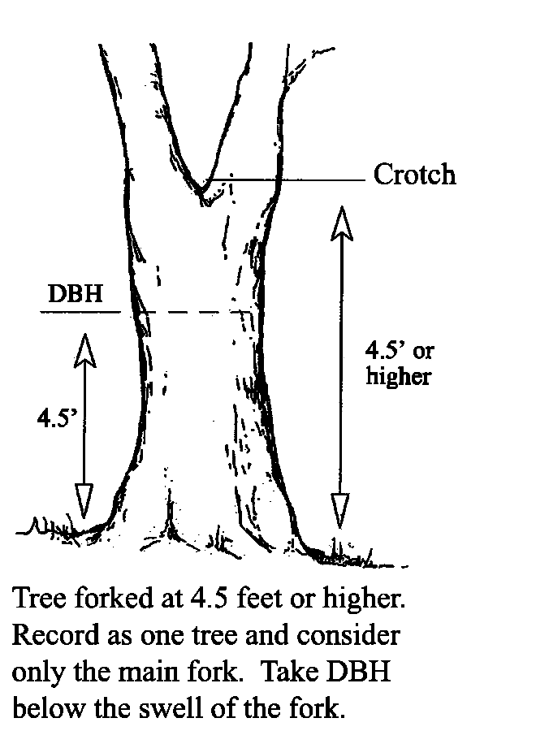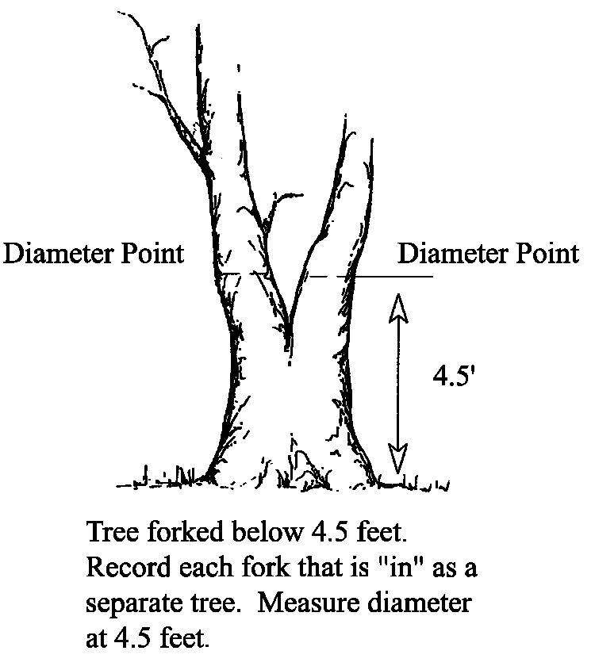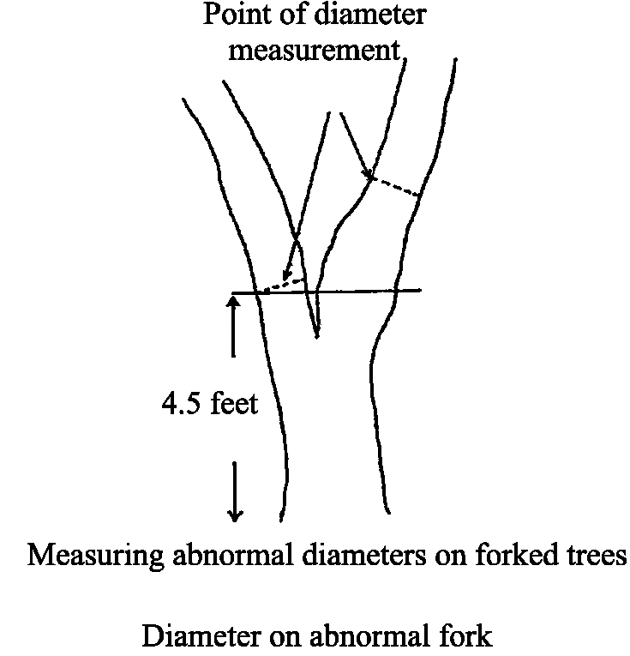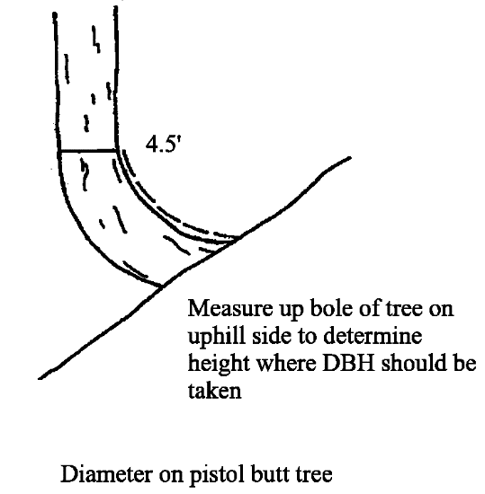
Figures borrowed from the USFS Field Sampled Vegetation Users Guide

2) Compacted Crown

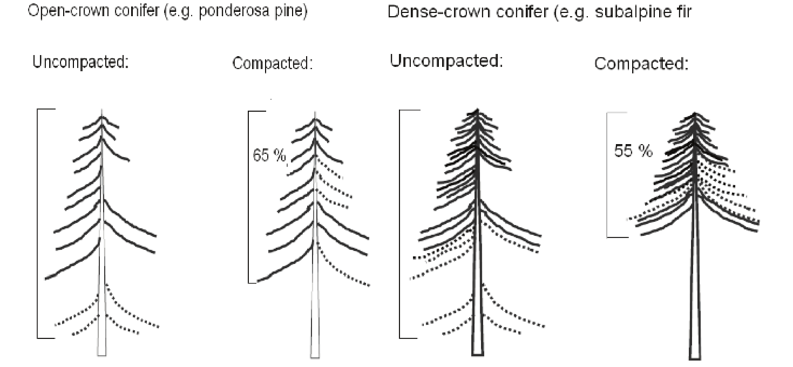

3) Snag Decay Classes
Code | Bark | Limbs | Top Breakage | Bole Form | Sapwood Decay
1* | Tight, intact | Mostly Present | May be present | Intact | None to incipient
2 | 50% loose or missing | Small limbs missing | May be present | Intact | None to incipient
3 | 75% missing | Few remain | Approx. 1/3 | Mostly intact | None to 25%
4 | 75% missing | Few remain | Approx. 1/3 to ½ | Losingform, soft | 25%+
5 | 75%+ missing | Absent | Approx. ½+ | Form mostly lost | 50%+ advanced
*Implies recent mortality, within the last 5 years.
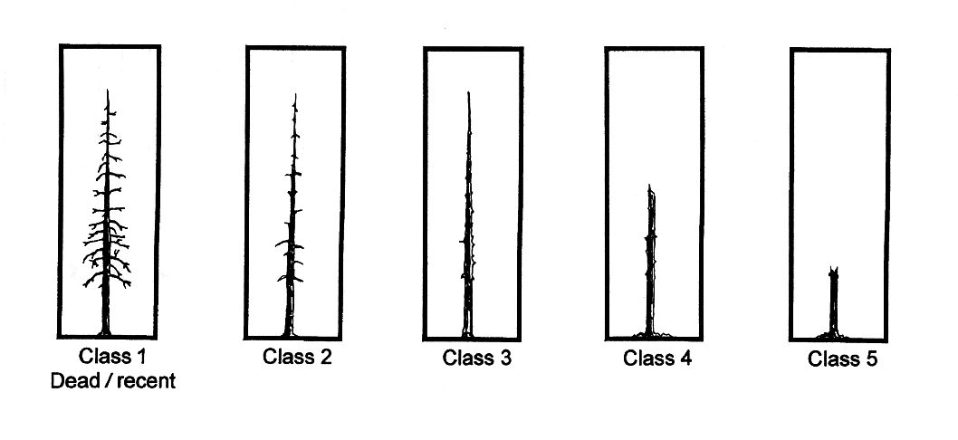

4) Percent Cover Estimation

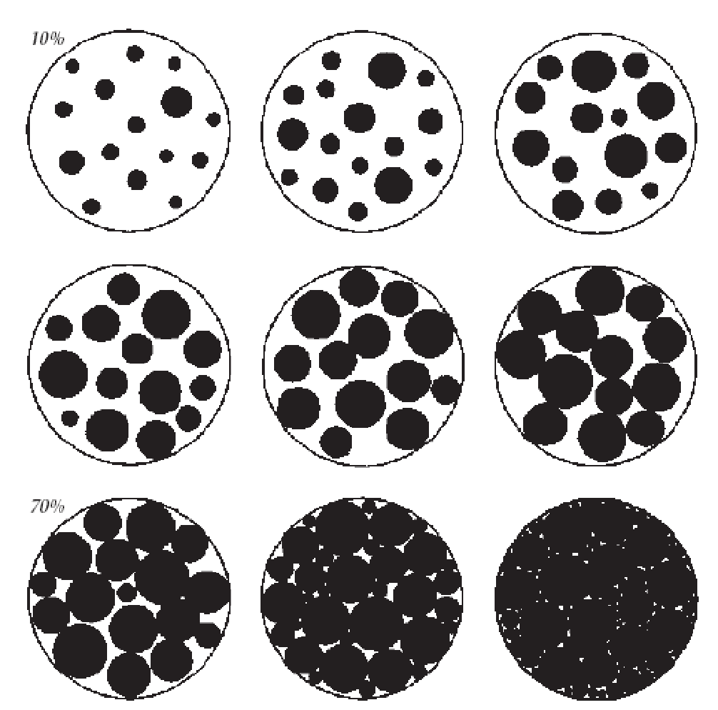

5) Species Code List

Species - Common | Common Code | Species-Latin | Latin Code
Bigleaf maple | BM | Acer macrophyllum | ACMA3
Bitter cherry | CH | Prunus emarginata | PREM
Black cottonwood | BC | Populus trichocarpa | POTR15
Douglas-fir | DF | Pseudotsuga menziesii | PSME
Grand fir | GF | Abies grandis | ABGR
Oregon ash | OA | Fraxinus latifolia | FRLA
Pacific dogwood | DW | Cornus nutallii | CONU4
Pacific madrone | PM | Arbutus menziesii | ARME
Pacific yew | PY | Taxus brevifolia | TABR2
Red alder | RA | Alnus rubra | ALRU
Lodgepole pine | LP | Pinus contorta contorta | PICOC
Silver fir | SF | Abies amabilis | ABAM
Sitka spruce | SS | Picea sitchensis | PISI
Western hemlock | WH | Tsuga heterophylla | TSHE
Western red-cedar | RC | Thuja plicata | THPL
Western white pine | WP | Pinus monticola | PIMO3

Imagery Field Guide

Purpose of Photo-Point Monitoring Protocol
The Olympic Forest Collaborative (OFC) is monitoring forest management actions that take place on the Olympic National Forest that have OFC involvement. The overarching goal of monitoring is to quantify the outcomes of forest management actions, track how well forest conditions are approaching the desired forest conditions, and to inform best management practices in future ONF timber harvest projects.
Photo points are permanent locations from which photographs are taken pre-harvest (where possible), and at regular intervals following harvest. These time-series photos show the changes to the forest. Several photo points will be established at each harvest area, and landmarked on-the-ground and with GPS so they can be re-used over time. Drone aerial imagery may also be used.
Objective: Provide photographic documentation of changes to specific points in the forest over time.
Methods: Photographs from permanent, landmarked points at intervals over time.

In Office Preparation
- Select plot locations based on digital and field recon data (if available). Minimum 1 plot per 10 acres, and 5 plots per forest strata. Plots used for Vegetation Survey may be reused for photo-point plots. Identify additional photo plots to supplement Vegetation Survey plots in order to capture specific areas of interest.
- Prepare digital maps for use in the field. Also export a layer of plot center points as a GPX and KML for use in navigation apps.

Equipment
- High resolution digital camera
- Tripod with leveling bubble
- GPS device: Garmin GLO or similar for general navigation, WAAS-enabled and/or differentially-corrected GPS for plot centers
- 5 ft length of PVC pipe for plot center
- Compass declinated to 16° E
- Orange spray paint for plot center
- Tablet with navigation maps and previous photos
- Jake staff

DATA COLLECTION

Location
- Navigate to plot center. Install PVC pipe so about 3 ft are above ground. Spray paint with orange. Write the plot ID on the PVC pipe using a Sharpie. You may offset the plot center by 100 ft along a random azimuth if there are hazards or non-forest at the original plot center (cliff, stream, bees, road, etc.).
- Take photos of the plot center that capture the location of plot center to allow for relocation of the plot during re-measurements. Record azimuth and distance from plot center, as well as azimuth of each photo.
- Choose a large-diameter tree that is likely to be retained in a harvest as the bearing tree. On the back of a boundary tag, write the plot number, and distance and azimuth to the plot center. Record this information on the datasheet, as well as the tree species, DBH, and tree number.
- GPS the plot center using a device rated for sub-meter accuracy, letting the device average points for a minimum of 15 minutes. Label the point with the unit name and plot ID, the letter “P”, followed with the 6-digit date as follows: Queets01_P_022019. If your GPS software allows, write down the GPS coordinates once the point is complete.

Point Photography
- Set up the tripod so it is directly above plot center and mount the camera. Ensure that the platform is level using the tripod bubble level.
- Photograph a piece of paper with the unit name, plot ID, and photo angles (see below) written on it.
- If establishing a photo-point
  - Select 2-3 angles that capture the forest conditions and interesting features. Measure these angles with the compass and record them.
  - Place Jake staff in the ground 10 ft directly in front of camera
  - Photograph each angle in the order they were recorded on the datasheet
- If remeasuring a photo-point
  - Identify the angles previously recorded at this photo point. For each angle, line up the camera with the angle using the compass.
  - Review the photo from the previous measurement. Identify “anchor” features in the photo near the borders of the frame. Adjust the angle of the camera to align the framing as closely as possible with the previous photo
  - Place Jake staff in the ground 10 ft directly in front of camera
  - Photograph each angle in the order they were recorded on the datasheet

Drone Photography
Stay compliant: Flights may only be conducted by certificated UAV pilots complying with FAA regulations. Check local airspace restrictions and additional landowner requirements before flying.
- Weather
  - Lighting: Imagery acquisition should take place on a day with high overcast (preferred for even lighting) or on a cloudless day with sun angle within 10 degrees of solar noon. Imagery acquisition should not take place during rain or under partly cloudy skies.
  - Wind: Imagery acquisition should take place only when wind speeds are consistent (not gusty) and at a level manageable for the drone. Subtract the average wind speed from the drone’s top air speed and be sure that the difference comfortably exceeds the desired ground speed.
- Flight parameters
  - Program a preset flight path rather than operating under manual control.
  - The flight path should follow topography to maintain a height above ground varying by less than 50 ft across the entire unit.
  - The average flying height should be approximately 50-100 ft above the dominant canopy height.
  - While collecting imagery, the drone’s ground speed should be approximately 2-4 m/s.
  - The flight plan must allow for 30-50% sidelap between adjacent flight lines.
- Sensor
  - The camera must record at least standard red, green, and blue bands and may additionally record one or more near-infrared bands.
  - The camera may use any style of sensor, i.e., push-broom, whisk broom, frame camera, etc., so long as the resultant imagery can be stitched and orthorectified.
  - The camera’s focal length must allow for clear images without edge distortion. Focal lengths of 25-50 mm are preferred.
  - The same sensor must be used in monitoring an entire project. This includes pre/post flight pairs. It is acceptable to use different sensors for different project areas.
- Timing
  - Flights should be made during the late spring or early summer to best capture all vegetation.
  - Flights must be made during the last spring/summer before treatment, the first spring/summer after treatment, and the fifth spring/summer after treatment. Longer-term monitoring must be decided case by case.
  - Additional flights must be made the first spring/summer after significant disturbance events.
  - Repeat flights should be made as close to the original flight date as possible.
- Georeferencing
  - At least three points on the ground must be monumented with visible targets set in locations open to the sky during the flight. A Secchi disk pattern 6-10 in. in diameter makes the best target.
  - Targets must be georeferenced with the highest-quality GPS available.

Learning Framework
The OFC monitoring and evaluation approach draws on a number of efforts by the Forest Service’s Pacific Northwest Research Station, the Pacific Northwest Region, individual National Forests, and various collaborative groups in the region. Efforts to develop and implement adaptive management (AM) concepts have evolved substantially since the early days of the idea (Walters and Hilborn 1978, Holling 1978, Lee 1993). The Northwest Forest Plan is itself an application of adaptive management, and an adaptive management framework was adopted in 2005 by the federal agency leaders implementing the Northwest Forest Plan (Fig. 1).
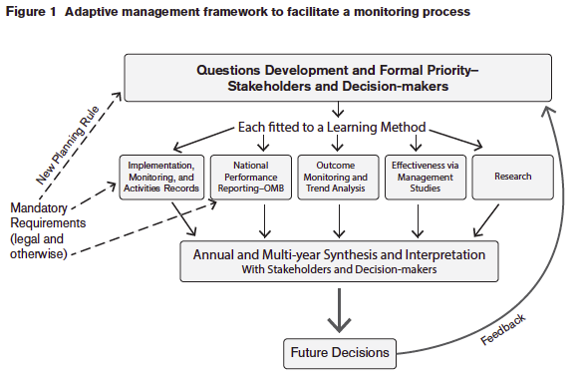
Figure 1. The adaptive management framework developed for the Regional Interagency Executive Committee in 2005, as slightly modified by DeMeo et al. (2015).
Monitoring is routinely included as a component of land management; however it is often implemented in ways that fail to achieve the goal of informing future decisions, i.e., completing the adaptive management cycle. Various shortcomings have been identified (following DeMeo et al. 2015), including:
- Poorly defined and constructed monitoring objectives,
- Insufficiently broad user and stakeholder involvement in the monitoring process,
- Lack of institutional funding and support,
- Unrealistic monitoring goals and expectations,
- Lack of prompt reporting on monitoring results to agency leadership and the public,
- Failure to put what was learned into broader spatio-temporal or integrated policy contexts, and
- A narrow research-focused approach.
The learning framework developed for the Northwest Forest Plan (Fig. 1) was an attempt to address and overcome these process failures. This framework reflects what is generally accepted as the best currently available science on adaptive management, compiled by the Department of Interior (Williams 2012). For our purposes here, we adopt the version developed for the Collaborative Forest Landscape Restoration Projects in general and the Lakeview Stewardship group in particular (DeMeo et al. 2015). The core idea is to place monitoring and evaluation into a broader learning and adapting framework. Five premises underpin this framework:
- Problem framing is needed to develop useful and important questions,
- Questions are important when they are linked to future potential decisions,
- Each question has an optimal learning method,
- Hypotheses tested by monitoring data from field experience fuel changes, and
- Open feedback channels, with thoughtful evaluations, are the engine of change.

Applying the framework
A series of steps (boxes and arrows in Fig. 1) are applied to existing and new projects to establish a learning prioritization that uses limited monitoring funding to yield the greatest benefit. Multiple iterations are needed to define this prioritization before setting monitoring into action.

Step 1. Identify key questions and associated learning methods (cycle through step 2 and back enough times to end with a formal question priority)
OFC has the advantage of being given its first key question when it was first established by Representative Kilmer:
Question 1. Can timber volume harvests be increased on the Olympic National Forest above current harvest levels using an ecological approach and goals while maintaining and improving the ecological and social functions of the system?
This broad question suggests important, more specific, sub-questions to be evaluated:
Question 1.a. Is it possible to speed development of late-successional habitat through thinning and provide ecological benefits at the same time?
Question 1.b. Are there different / better / worse ways to thin that speed habitat development, assist species, increase diversity in the landscape and understory, and provide increased harvest volume?
Question 1.c. Can (does) Collaborative involvement increase harvest volumes by reducing conflicts and working cooperatively to implement goals?
Question 1.d. Can (is) community wellbeing be improved with increases in harvest volume from thinning projects?
Ultimately, a wide range of questions need to be raised and evaluated, because choices will have to be made given limited capacity and resources to address them. This might be best tackled in a strategic planning session with the ONF, and should be revisited annually. OFC will consider different types of questions, for example the group might decide on:
Question 2. (example only) How do local communities like the alternative thinning practices being tried?

Step 2. Assess relevance to future decisions (cycle back to step 1 enough times to end with a formal question priority)
Potential questions are checked and ranked for importance to possible future decisions. This is where some questions are dropped.

Example of possible sequence of discussion:
Questions 1.a and 1.b are clearly important to many aspects of environmental wellbeing (ecological processes, biodiversity, endangered species, other species, etc.) that drive decisions on the ONF. Past practices reduced ecological function, harvest volume, and some aspects of wellbeing (resulting in the Northwest Forest Plan). Unanticipated consequences of that decision are now being recognized, which might suggest new directions for the Forest. One example is food supply for deer and elk, birds, and pollinators that seems limited by monoculture plantation second-growth conifer stands.
Questions 1.c and 1.d address community wellbeing issues, i.e., economic activity that directly and indirectly affect local communities. The past boom-bust public forest cycle, combined with other factors like automation, affected economic activity leading to persistent poverty in many Peninsula communities, perhaps more so than was first anticipated. Increased harvest volume has the potential to improve community conditions, although current Forest Service harvests are minor compared to production on state and industry lands.
Answers to this first set of questions will be relevant to future planning, including consideration of a major plan revision (due soon). Discussion of these may lead to other questions to cycle back on. For example, how much thinning is acceptable? Should thinning be allowed in stands over 80 years old?

Step 3. Determine practicality and effectiveness of learning method needed to address each question (then cycle back to question list)
Again, this step is applied to the full set of questions. Key aspects of this step are to see what learning method is needed to provide a real answer, and the extent that that method is available. This step is very important when designing new projects. Minor changes to project design may provide large benefits. One example is to double the project area and add a randomly chosen control (manage 1 part; monitor both treated and control). Adding pre-treatment monitoring may help in some cases.
Example of possible sequence of discussion:
Question 1.a. Is it possible to speed development of late-successional habitat through thinning and provide ecological benefits at the same time?
This question cannot be answered using existing databases. We would have to rely on outcome tracking, effectiveness monitoring with management studies, or possibly research. The best method of these three is management studies where thinning can be compared to not thinning at an operational scale (too big for research). The case study method of tracking a single application will not provide much evidence because the comparison with untreated stands is unavailable and using nearby untreated areas post-facto will not be convincing without a pre-treatment determination of similar initial conditions. Which ecological benefits to measure is not easy to determine; see discussion in Step 4 later.
Question 1.b. Are there different / better / worse ways to thin that better speed habitat, assist species dependent on understory, and provide increased harvest volume?
This is a minor deviation from 1.a. that suggests a comparison of different thinning strategies and measuring effects on other species dependent on understory. The management studies method is clearly the best for this type of question. Ideally a set of adjacent or nearby project areas with different strategies would be applied as a block in different areas of the Forest. This approach is far less intimidating than most people think, and might be the way to set up larger areas and generate the highest quality of evidence.
Question 1.c. Can Collaborative involvement increase harvest volumes by reducing NEPA or other processes?
This is a valid and important question. Probably the best approach would be as a research case-study given the likelihood of complex factors. This question requires keeping good records on FS and Collaborative activities and costs. Assessments of alternative approaches that might have been or could be taken will need to be analyzed as well.
Question 1.d. Can community wellbeing be improved without major increases in harvest volume?
Determining community wellbeing is a major challenge. Tracking changes in people’s opinions before and after thinning requires a research method. A variety of questionnaires, interviews, focus groups, field trips, interpretive trails and other forms of feedback would likely be needed to gauge changes.

Step 4. Choose the minimum set of measures needed to answer the question (again cycle back to earlier steps as needed, especially when measures prove unpractical)
Example of possible sequence of discussion:
Question 1.a. Is it possible to speed development of late-successional habitat through thinning and provide ecological benefits at the same time?
Characteristics indicating trends toward late-successional habitat may include typical late-successional management indicators such as conifer size, age and density; canopy layers; snags; and downed wood. It may also be important to consider additional measures, perhaps maximum branch diameter and mineral soil organic matter and nitrogen. It may also be valuable to consider tree and understory species, including excessive hemlock regeneration. These measurements can be made on permanent plots of various designs. Many also may be able to be extracted from lidar data, including pre- and post-treatment drone-based lidar.
Question 1.b. Are there different ways to thin that better speed habitat, assist species dependent on understory, and provide increased harvest volume?
Animal species dependent on openings can be tracked with a variety of methods including game cameras, continuous audio monitoring, pellet counts and paired exclosure (fenced) plots.
Monitoring other aspects of environment wellbeing is more complicated and will require long-term commitment. Species with large home ranges like owls and murrelets cannot be tracked at the scale of a management unit (although elements of their habitat can be). In ephemeral stream riparian areas, measures of litterfall quantity and quality and/or insect diversity might be considered as an indicator of the aquatic food chain.
Wind damage post thinning is a potential issue. This can be determined with field plots and repeat lidar. Topographic exposure, soil depth, and other factors may be good covariates. Interpretation is critical with all of these measures. For example, windfalls are a natural process that have actually been diminished by management (trees are felled before they can be blown over).
Question 1.c. Can Collaborative involvement increase harvest volumes by reducing conflicts or other processes?
Timber cruise and log-load data could be collected and potentially linked to individual units. Ideally equipment records might help determine logging costs (which influences net receipts). Safety and other factors are usually recorded in operations studies. Most often these are comparisons of alternative approaches. Consideration will be needed in determining if increased volume is best achieved by: (1) FS staffing costs covered by the Collaborative; (2) intensity of thinning; (3) area of thinning; or (4) road access and related engineering factors.

Step 5. Analyze data and put into a broader context of what is known before drawing conclusions (after measures have come in)
It is important to review what is already known before analyzing results. A key outcome from each pass through the learning cycle is to identify new, better questions to follow in subsequent monitoring.

Step 6. Find ways to effectively share conclusions, and accept alternate conclusions
Feedback to future decision making, including prioritization of learning questions, needs to be planned to be effective. OFC and the ONF, and members of the public, must work together to participate in learning. It can be difficult to overcome the challenges associated with personnel turnover and the associated loss of institutional memory; however, this may be helped by good recordkeeping. Even without consensus, future debate will be better informed.

Literature cited
Demeo, T., Markus, A., Bormann, B. T., & Leingang, J. (2015). Tracking progress: The monitoring process used in collaborative forest landscape restoration projects in the Pacific Northwest.
Holling, C. S. (1978). Adaptive environmental assessment and management. John Wiley & Sons.
Lee, K. N. (1993). Compass and gyroscope: integrating science and politics for the environment (No. ISLAND-0380/XAB). Island Press, Washington, DC (United States).
Walters, C. J., & Hilborn, R. (1978). Ecological optimization and adaptive management. Annual review of Ecology and Systematics, 9(1), 157-188.
Williams, B. K. (2012). Reducing uncertainty about objective functions in adaptive management. Ecological Modelling, 225, 61-65.

Study Plan: Queets Corner

Introduction
The Olympic Forest Collaborative is laying out the Queets Corner stewardship project to meet the Collaborative goals of increasing timber harvest while also meeting ecological objectives. Increasing harvest volume is expected by (1) collaborative assistance in laying out the sale allowing ONF personnel to focus on other projects, (2) using a variable density Designation by Prescription (DxP) rather than the typical Designation by Description (DxD), and (3) harvesting larger gaps. Monitoring of the Queets Corner stewardship project is being designed to provide valuable knowledge to guide other stewardship projects and learning efforts around the ONF.

Key questions
- Does DxP provide more harvest volume and more revenue for stewardship than DxD?
- Does management shift conditions toward target conditions?
- Do residual trees respond to openings?
- Do understory plants respond to openings?
- Are responses different in higher and lower productivity portions of the unit?
- Did harvest implementation go as planned (volume, windthrow, soil disturbance)?
- What are the most efficient monitoring protocols that could be used on other OFC projects?

Potential additional questions
- How do visitors like the unit after harvest?
- Are elk and deer more commonly found in thinned compared to unthinned portions of the unit?
- What is the benefit of stewardship revenue from this project?

Expected outcomes (hypotheses)
- Implementation will occur as planned, meeting target volumes with minimal soil disturbance.
- More volume will be produced because of VDT approach; more net revenue will be produced because of lower costs using DxP; ONF personnel time is reduced because of OFC assistance.
- VDT prescription will send portions of the unit on a faster trajectory toward goal of late-seral habitat conditions (increased proportions of tree species other than hemlock, lower tree density, and faster individual tree growth) compared to adjacent unthinned forest.
- Residual trees in patches with more light will respond to harvest openings more than similar-sized trees in patches with less light. Specifically, gap > matrix thin > unthinned. Effects will increase with time and as leaf area per tree increases.
- Understory will rebound quickly with increased light in terms of cover, biomass, and diversity, although this may be tempered by increased browsing. Measures of suitable habitat for early-seral neotropical birds and insects, including pollinators, will increase.
- Responses will be greater in high versus low productivity parts of the unit (as measured by average tree height) because of lower initial tree density, better soils, and a higher live crown ratio in high productivity stands.

